CS795/895 Practical Machine Learning (Spring, 2024)

## Project I

Due: Feb. 23, 2024

The first project is one of Kaggle’s past challenge of “Plant Pathology 2021 - FGVC8.”

<https://www.kaggle.com/c/plant-pathology-2021-fgvc8>

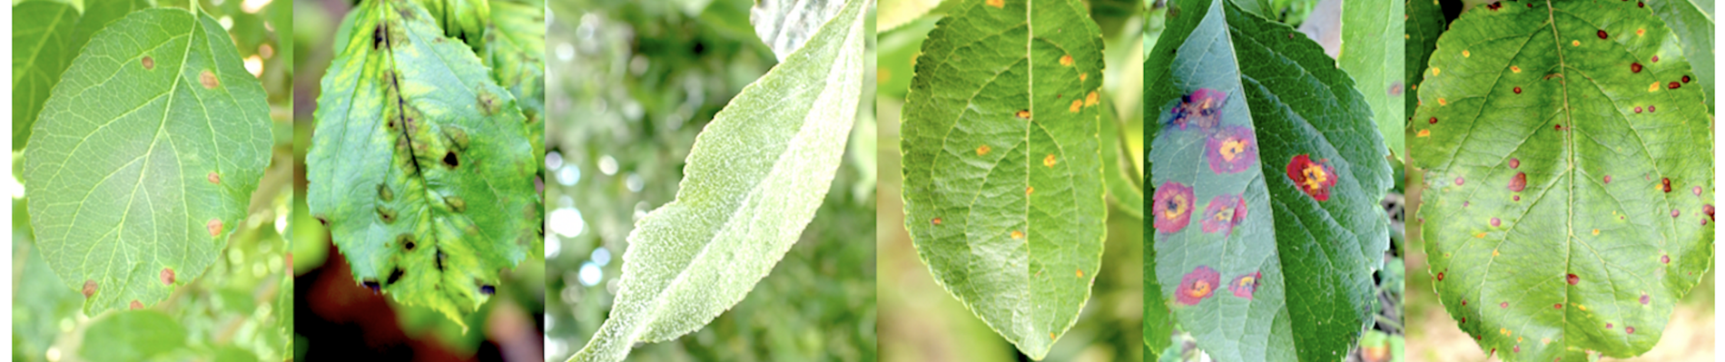

Students are required to perform this project in a team of 1-2 students. You are required to write a machine learning program (kernel) to generate predictions on a given leaf image to a particular disease category. You are required to write a project report based on the results of your project.

Here is an example of the layout of your project report paper.

1. Problem Definition.

Simply describe how you model the “Plant Pathology 2021 - FGVC8” problem.

2. Methods

Provide detailed description on your methods, machine learning model/architecture, data processing/preprocessing, feature selection/extraction/engineering, implementation details (pseudo code, flow chart, etc.), and training/testing/validation process. If you build your program on top of somebody else’s program, make sure you reference. It is important to specify clearly what you have implemented/contributed.

3. Results

Describe the performance of your ML model, what is the accuracy, precision, recall, etc. for task 1. Analyze the results you get, for example, how do methods/strategies lead to a better solution? What do you learn from this project? Use figures, charts, and tables to assist your analysis. You can also compare your results with the Kaggle leaders.

4. Conclusion

Provide your conclusion. Do you achieve your goal? Why or why not? If there a way to do it better?

**Delivery form**The delivery form of this assignment should be a 5-page document in MS Words using IEEE double column format and a jupyter notebook file with descriptions and comments. Please submit your project report and program or jupyter notebook via canvas.